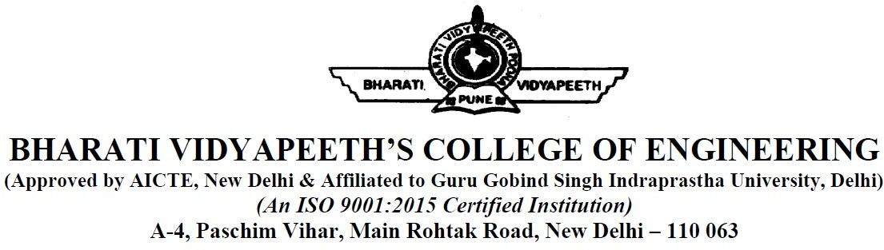

# Department of Electrical and Electronics Engineering

**Student Name….AMAN JAIN……..……….. Enroll. No……00451202816………….…..**

**Semester…………VIII………………...….. Date……………20/04/2020………….…...**

**Course Code.…………ETHS-402……… Course Title……….HVPE-II……………..**

**Case Study No.:…………………….......… Marks Obtained…………………………..**

**Max. Marks : …………………………… Evaluator’s Sign……………………….....**